Construction Specialties

Representative Electronic Order Write-Up Sheet

Two steps are required to complete the Representative Electronic Order Write-up Sheet:

Step 1: Search for the open quote and change it from a quote to an order.
Step 2: Fill out the Representative Electronic Write-up Sheet on screen and submit it.

Follow the scripts below to complete the two steps noted above.

Search for the original quote in the standard way, using the Architect Name, Bid Date, Customer Name, Quote Number or Project Name.

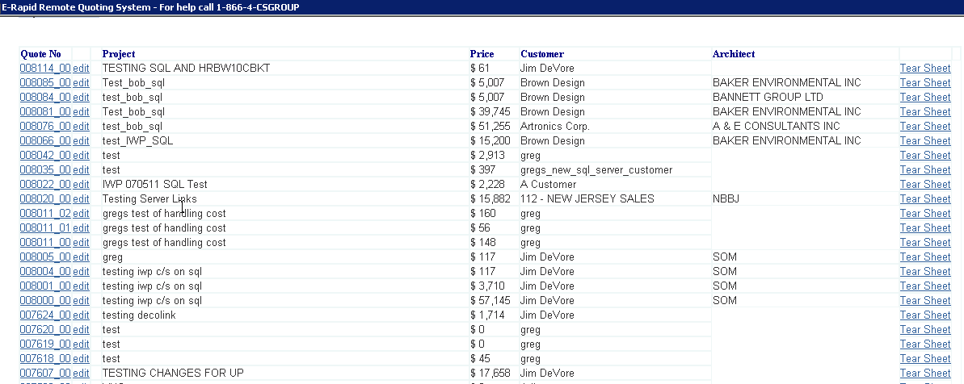

Click on the quote number of the quote to be changed to an order.

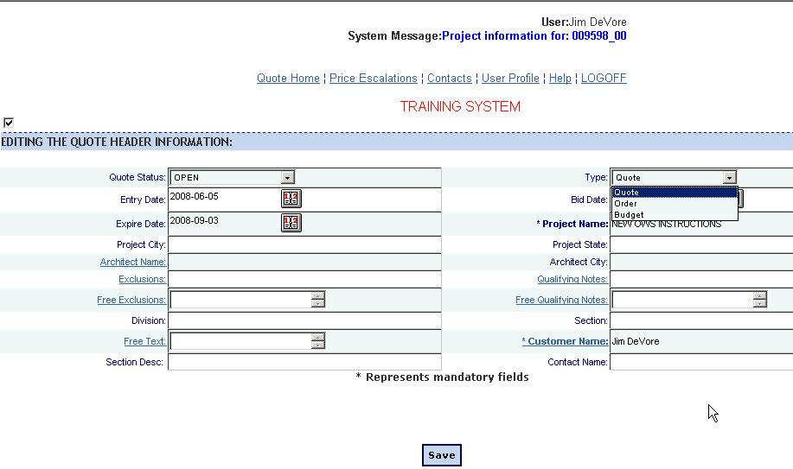

In the “Type” field, click on “Order.”

Click on the “Save” button at the bottom of the screen.

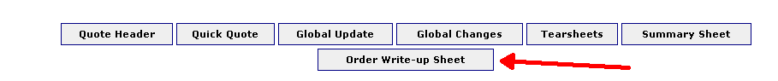

At the bottom of the screen, click on the button “ORDER WRITE-UP SHEET” to access the order write-up sheet.

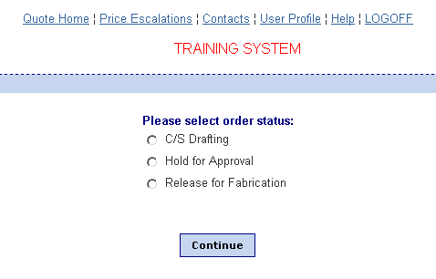
The first screen identifies how the order is to be processed.

C/S Drafting indicates that the order should be sent to the drafting department for approval drawings, template checks, or any verification that needs to be done by the drafting department.

Hold for approval should be used for Letter of Intent orders, orders requiring further clarification, or anything that can not be immediately released into the shop floor for fabrication and shipment.

Release for fabrication should be used for all orders that are ready for the shop floor and require shipment in a timely fashion.

The first two selections will skip the order validation process, and simply enter the order directly into the system to either be released to drafting or held for further information.

The last selection will run an order validation process, making sure that all necessary information is available for fabrication, such as color selection.

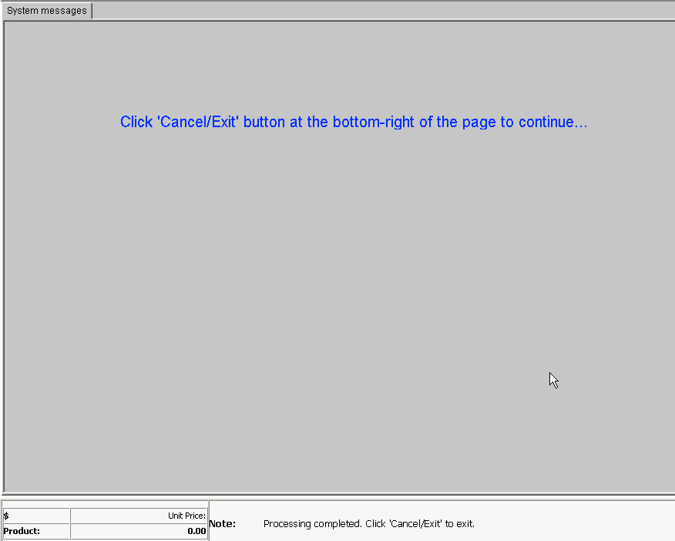
Release for fabrication will run a global update that checks for missing items. Hitting the cancel/exit button will do one of two things:

If items are still required to ensure the timely fabrication of the order, the update will return you to the line item screen, showing aborts where there is missing information.

If there is no missing information, the order write-up sheet will open, proceed as normal.

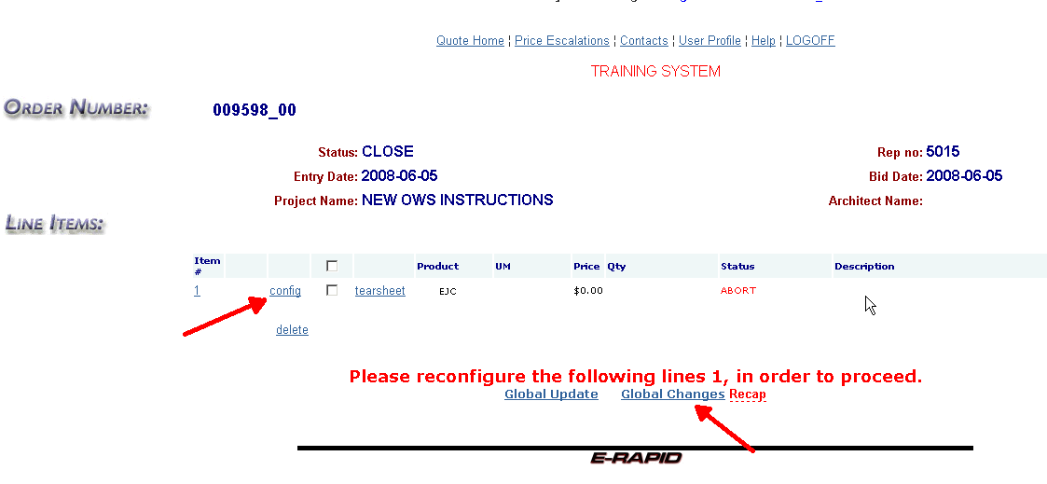
When there is an abort, simply click on the config button to eliminate the abort.

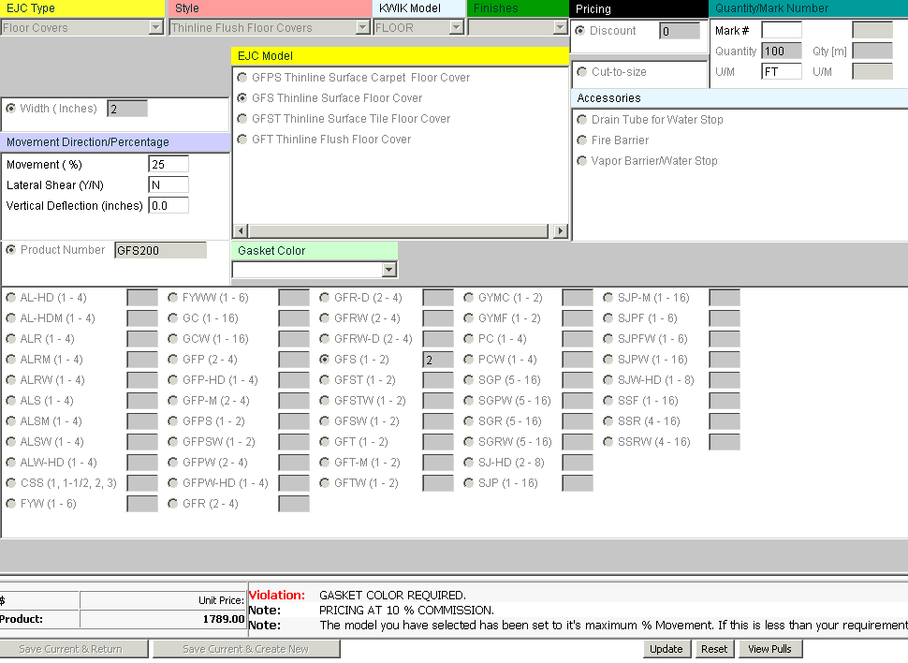
Using the config button will show a violation in the dialogue box on the lower right. Clear the violations by making the appropriate selections.

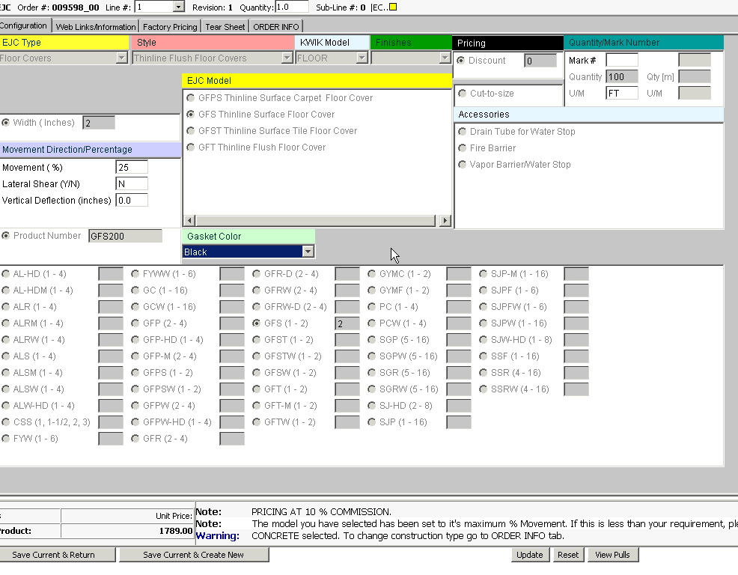
Once the corrections are made, hit the Save Current & Return button on the lower left.

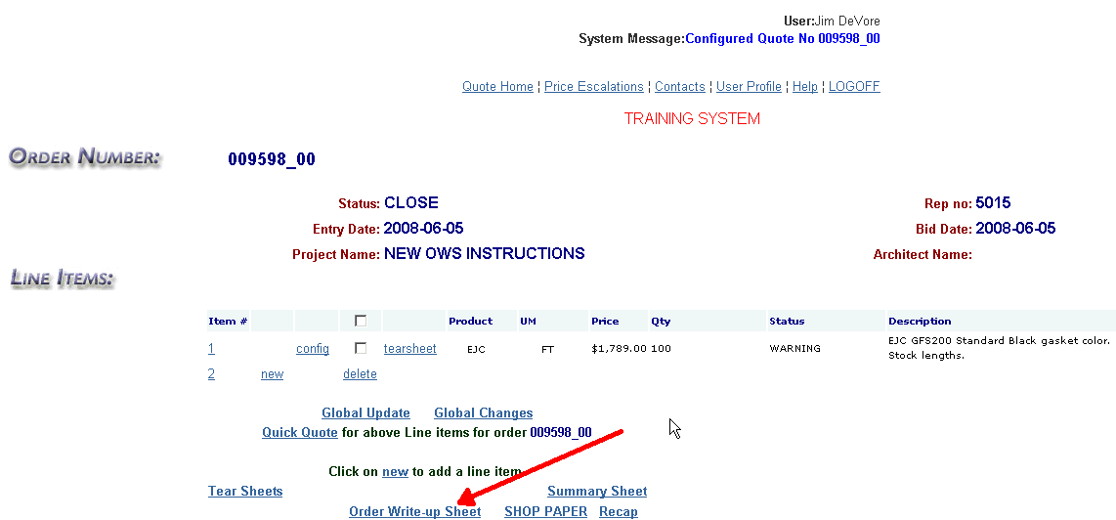
The aborts will clear, and you can resume the order write-up sheet. This will take you back into the order type screen, and keeping the release for fabrication selection will run global update again to complete the verification.

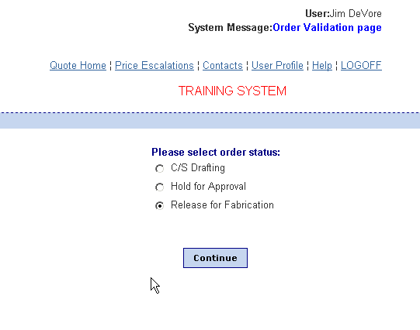
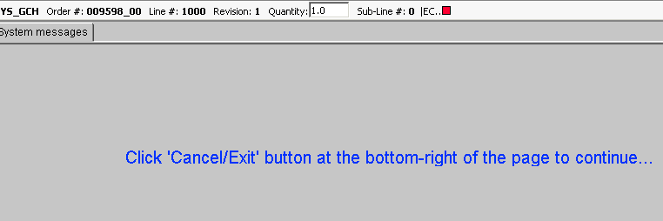
Hit the Cancel/Exit button on the lower right and it will take you into the order write-up sheet, providing all errors have been cleared.

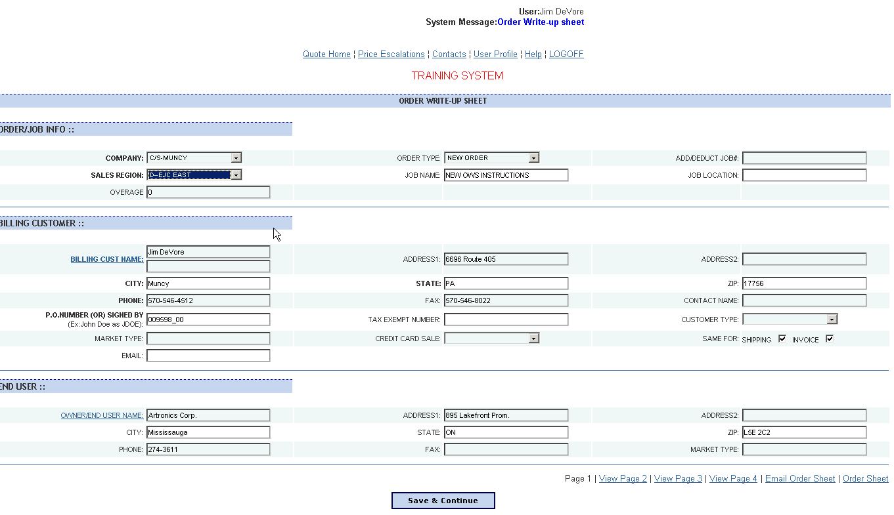
This is the first screen required for the write-up sheet. All bold boxes are mandatory selections/entries. An error message will pop up if those fields are not filled in, noting which are missing.

Note that the Billing Customer information will be automatically populated if the “Use for Billing” box was checked in your customer information. If this box was not checked the information will need to be entered.

If a credit card is to be used, click on the selector in the “Credit Card Sale” field. Two options appear:
- Credit Card – This selection will provide an area on the third write-up screen for entering the credit card information.
- Credit Card (Same as billing) – This selection will populate the credit card information with the billing customer’s name, address etc.

Note that the ship to information on the next screen will be automatically populated with the same ship to address as the billing customer if the “Same for shipping” box is clicked off at the end of the second block (Billing Customer). Additionally, if the invoice to address is the same, check that box also.

Hit Save & Continue when complete.

Each underlined title, such as BILLING CUST NAME:, are links to selection or entry boxes:

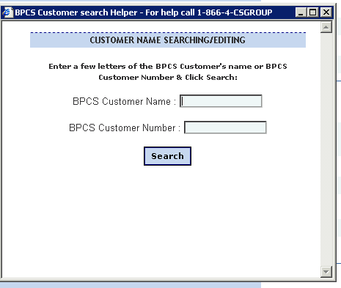

Simply type the first part of the data in and hit the search button in this instance. A list of potential items will populate the next screen, highlight the appropriate one and hit select.

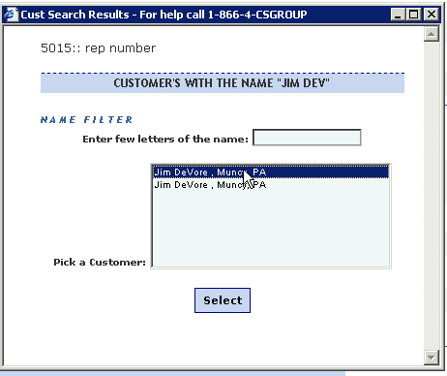

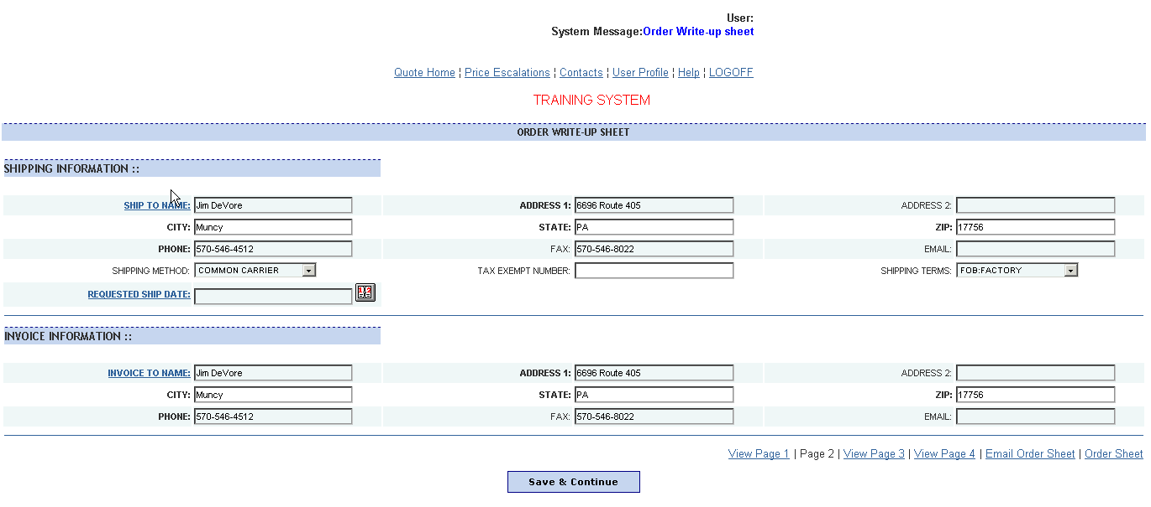

To go back to a screen at any time, click on the blue text at the bottom right of the screen. For example the “Page 1” text will take you back to page 1.

Fill out the second screen as required.

When complete, click on the “Save & Continue” button at the bottom of the screen.

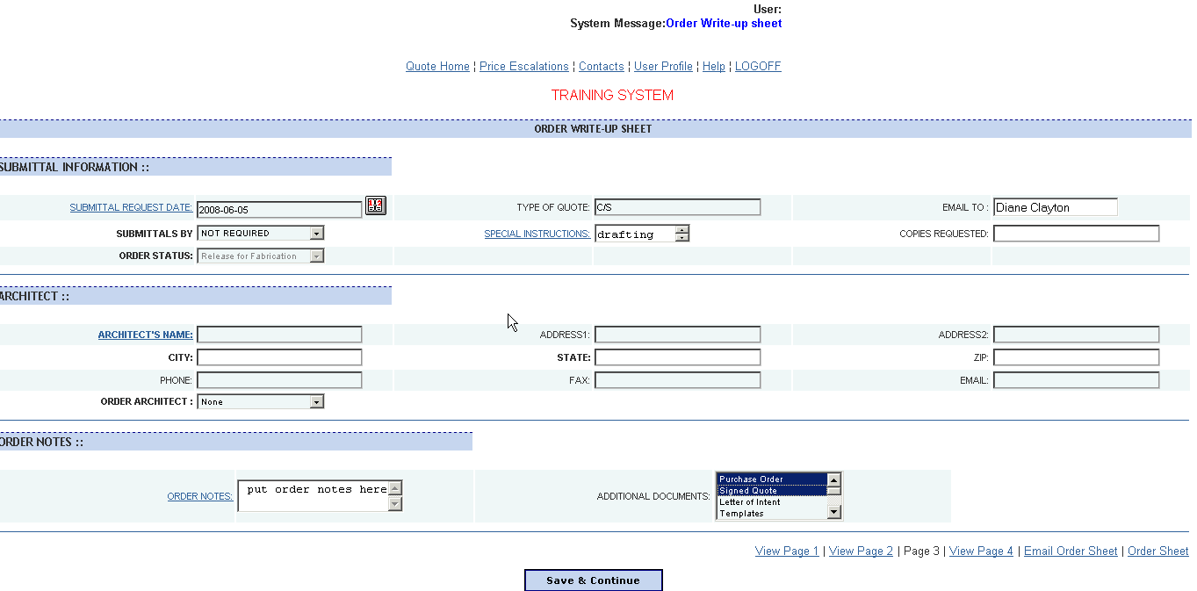
Fill out the third screen as required.

Note that the following two fields on this screen are underlined in blue lettering:
- Special Instructions (Under Submittal Information)
- Order Notes (Under Order Notes)
Both of these have text boxes that pop up by clicking on the underlined blue text.

Note that the “Order Architect” field has a drop down box. If there is not an Architect on the project, select “None” in that box.

To select multiple ADDITIONAL DOCUMENTS:, hit the Ctrl key and select all required with your mouse. To attach these documents to the electronic transfer, hit the upload button and follow instructions below (note that this only works with Save and Transfer on page 4).

UPLOAD FILES TO ATTACH
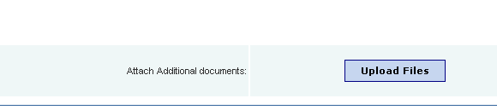
Hit Upload Files button.

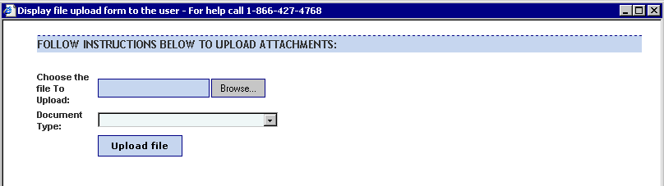
Select Browse button.
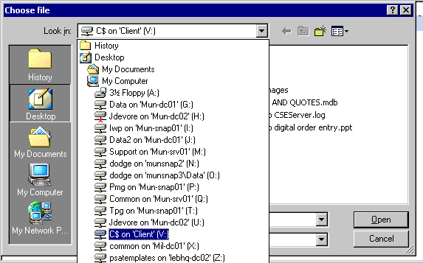
Select the network drive the attachment is stored on. Note: C$ on Client (V:) is your local hard drive.
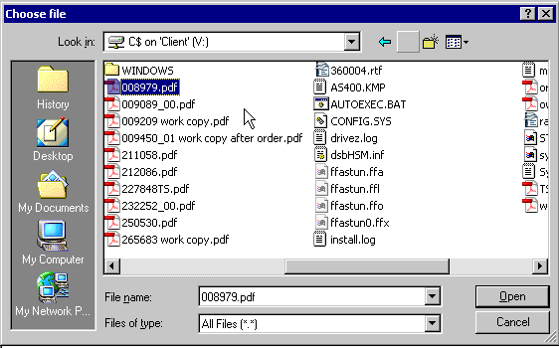

Select the file by highlighting it and hitting Open, or double click on the selection.
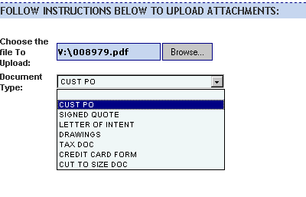
Identify the document by selecting the type from the drop down.

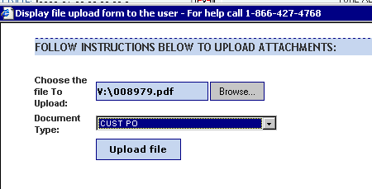
Select Upload file.
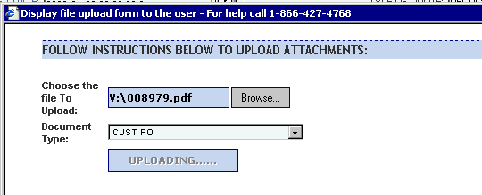
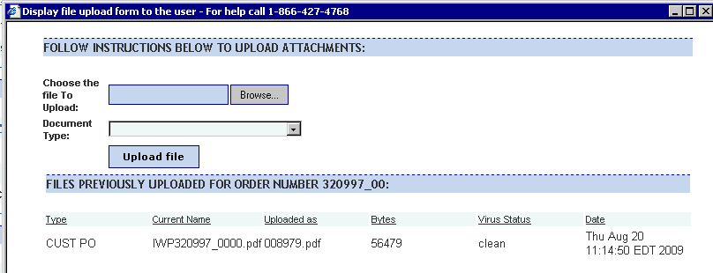
Repeat above steps to add more documents. Close this window when done.

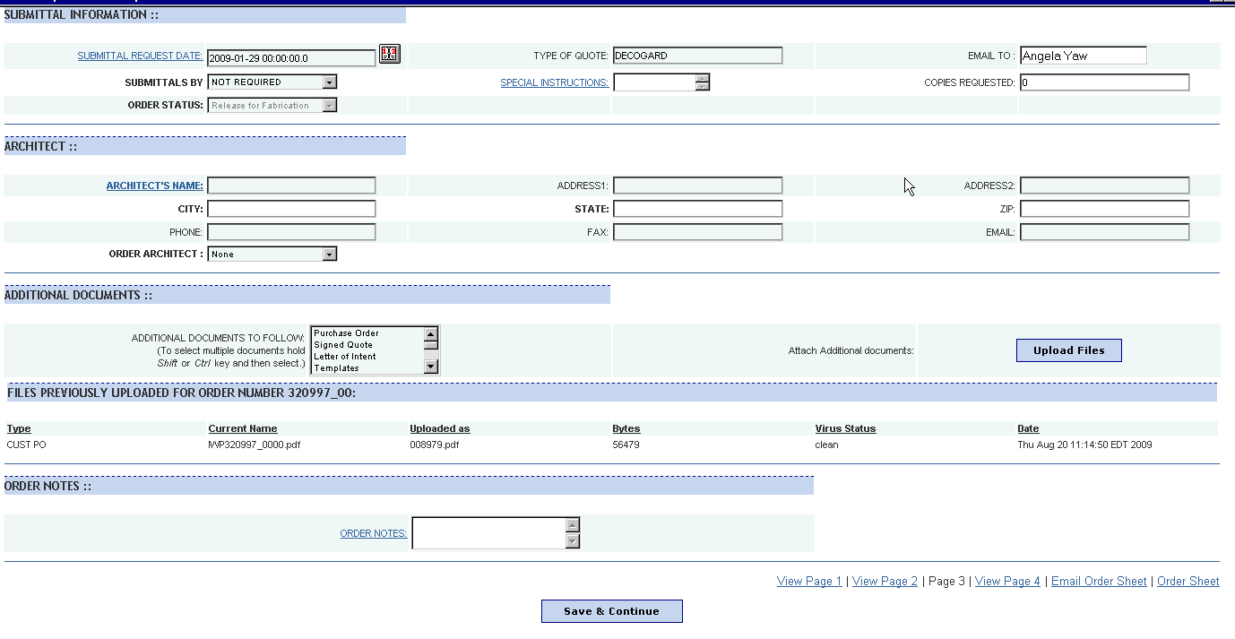

When complete, click on the “Save & Continue” button at the bottom of the screen.

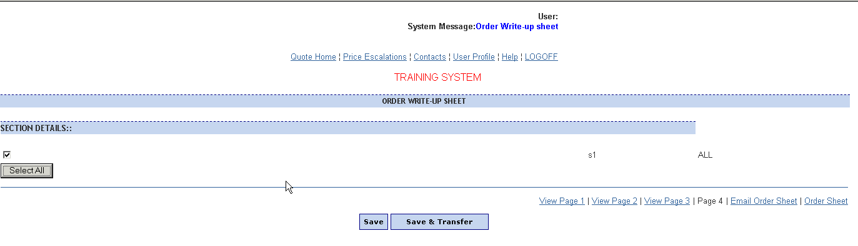
Select the appropriate sections to close, or use the select all button. Then, hit the Save button to simply save the information and get the order write-up sheet, or hit the Save & Transfer button to get the order write-up sheet and automatically transfer it to the appropriate order entry person within the corresponding SBU (along with all uploaded attachments).

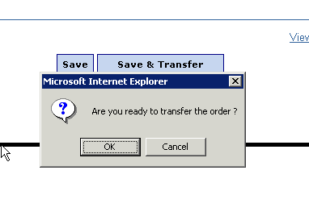
Save & Transfer will verify that you are ready to send this.

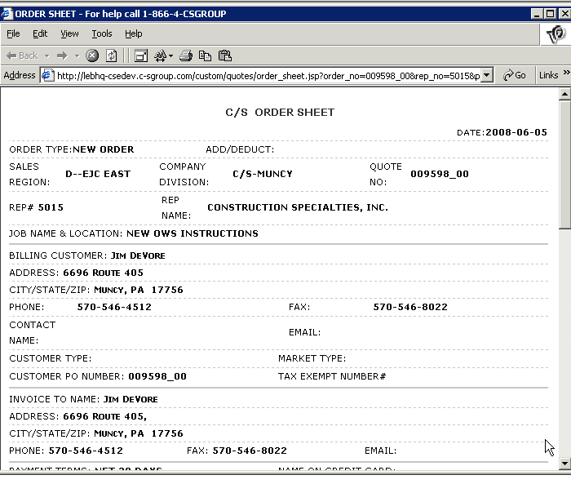

When complete, print out the order write-up sheet, or save a copy to your computer’s hard drive. NOTE: The write-up is always accessible through eRapid, so if you do not want to save it or print it, you can access it here at any point.

Fax or email the order write-up sheet to the appropriate contact along with the customer’s purchase order or signed quote, if you did not use the Save & Transfer button. You only need to send the PO and other documents if the Save & transfer button was used and you did not upload the files.

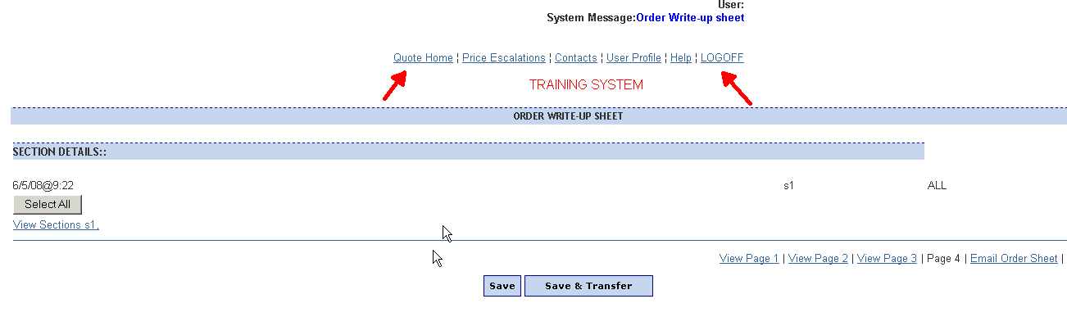

Close the Order Write-up sheet by hitting the X in the upper right. Then hit the quote home or logoff button to return to one of the main screens.

End

